|  |  |  |
| --- | --- | --- |
|  | **Rochester Institute of Technology**  **Golisano College of Computing and Information Sciences**  **School of Interactive Games and Media**  **2145 Golisano Hall – (585) 475-7680** |  |

**Data Structures & Algorithms for Games & Simulation II**

**IGME 309**

**Rotate by Quaternion**

This exercise follows lecture D6

1. In the root of the repository look for the example execution under _Binary. It will look like this:

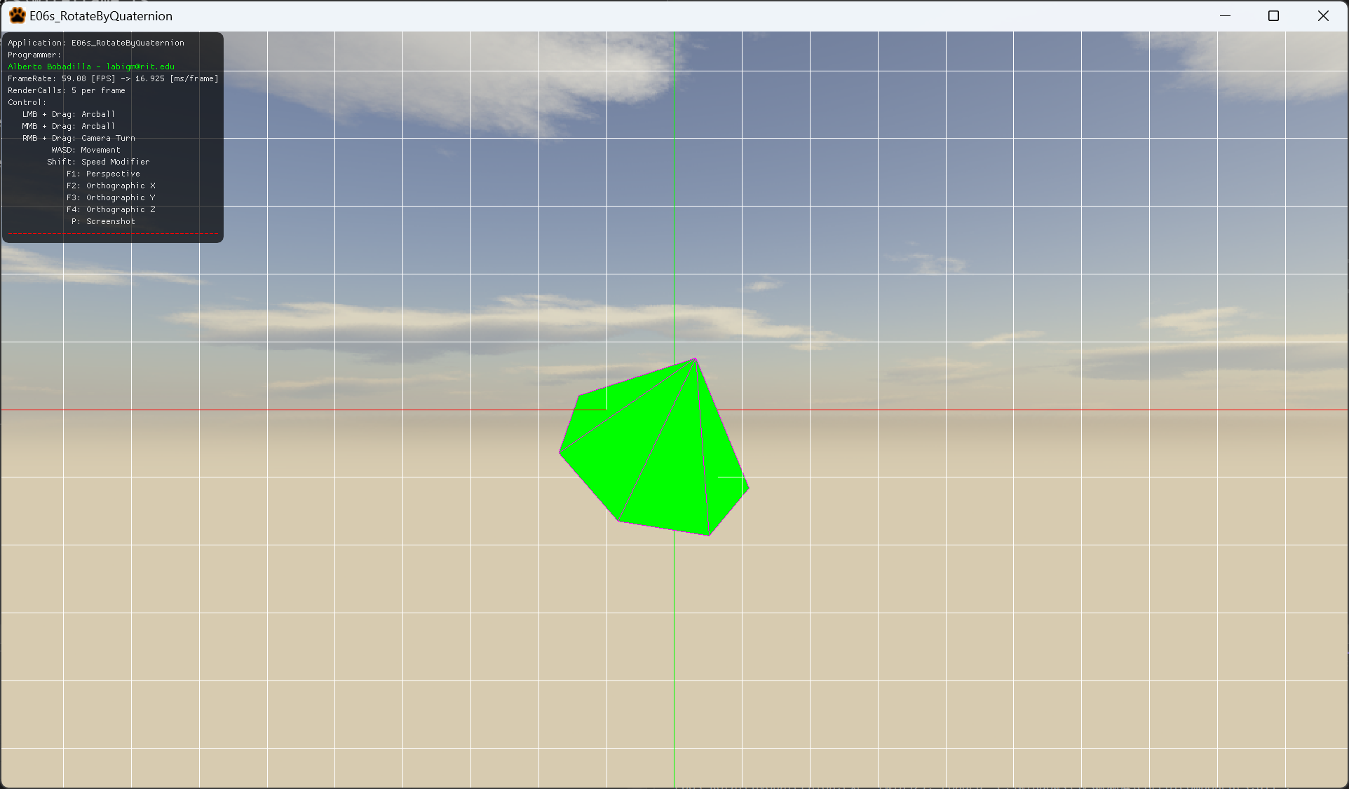

1. For this exercise you will recreate what happened on the project C05B_RotatePointClouds_Pt2, you will take a list of points and rotate it. In this case you will rotate it 45 degrees over all 3 axis at once. Your code will be executed in the file Mesh.cpp in the function GenerateCone. As this is the only file you will modify this is the only fine you need to submit in your delivery.
   1. Remember to use glm::anglAxis is the easiest way to create a quaternion given the information you have.
   2. glm::rotate will also return a vector3 instead of a matrix4 if used appropriately, this means, using quaternion and the vector you have to rotate by that quaternion. It may imply a bit of research on your end on how to use this function.
2. All your code will be coded in the mesh.cpp file in said function so this is the only file you need to submit to the dropbox in MyCourses, please do not zip this file.

